**Sprints 1 - 3**

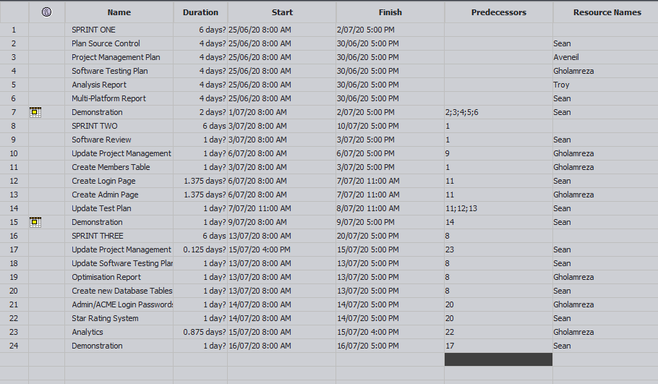

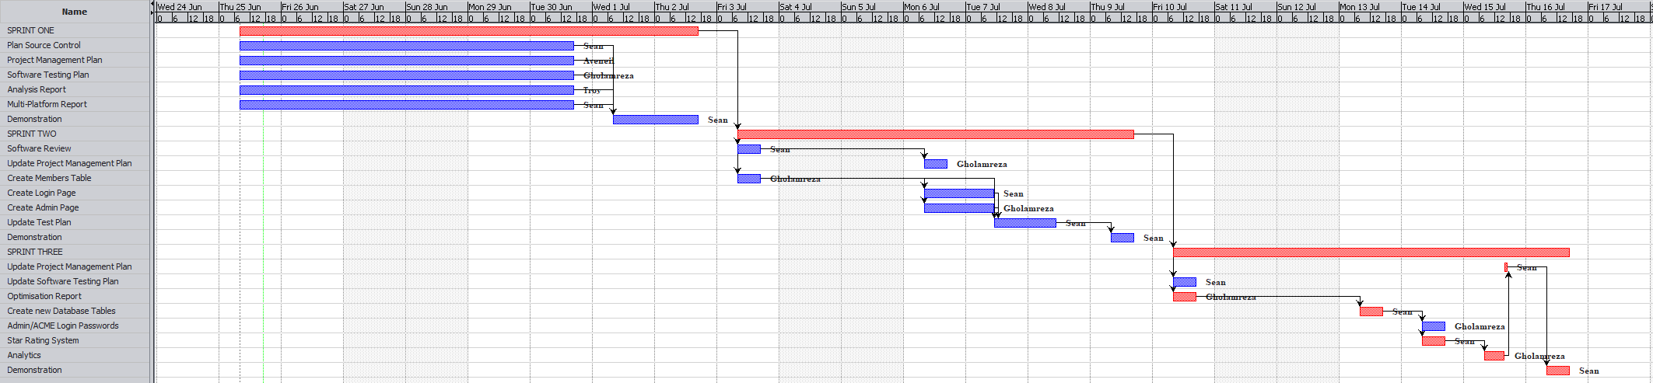

**Sprint 1**

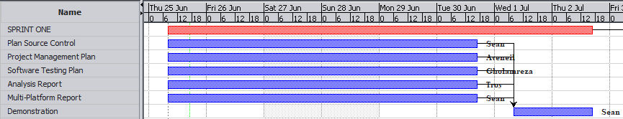

**Sprint 2**

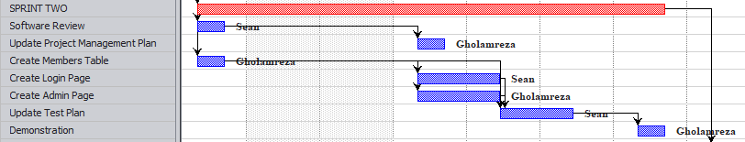

**Sprint 3**

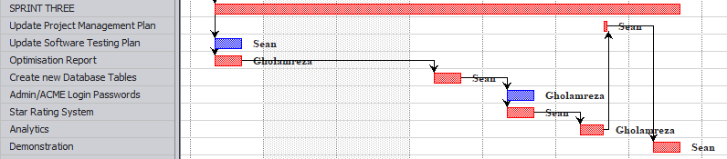

**Handover**

